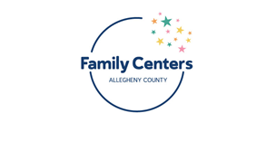
DHS/Site Director Update
Meeting Minutes
January 13, 2023
Attendance: Amy Engel (OCD), Emily Bengel (DHS), Susan Bertonaschi (DHS), Melissia Blakey (DHS), Brooke Generett Ware (Family Resources), Charlotte Byrd (UPMC), Courtney Macurak (SHIM), Casey Rich (South Hills/SHIM), Kelly Cavanaugh (Hilltop), Debbie Gallagher (COTRAIC), Dennis Robinson (Duquesne), Diona Jones (FOR), Doreen Glover (Hill District), Dionne Forney (DHS), Marylouise Fuga (Turtle Creek), Gladys Montanez (Latino Community Center), Donna Grzandziel (DHS), Rhonda Hall (OCD), Laura Hinely (DHS), Holly Cherpak (Steel Valley), Elaine Jans (Lawrenceville), Jawanna Warren (Clairton), Jeannie Dennis (Highlands), Laura Bosnak Thompson (McKeesport), Lorene Vollman (AIU), Lori MacQueen (Providence Connections), Lynette Drawn-Williamson (East Liberty), Gabrielle Glass (Providence/Northside), Amy Malen (DHS), Martha Sherlock (Family and Immigrant Connections), Michael Smith (Sto-Rox), Mary Napier (Braddock/Rankin), Nikisha Cunningham (Lincoln Park), Paulette Davis (Wilkinsburg FSC), Phylicia Tarpley (Wilkinsburg FSC), Rosamaria Cristello (Latino Community Center), Toni Beasley (Homewood), Victoria Goins (Urban League), Linda Vincent (OCD), Cara Ciminillo (Trying Together), Margaret Watts (Hazelwood), Claire Wever (DHS)
- Icebreaker/Welcome
- Happy January and 2023! January is National Self-Love Month! What are you doing this month to show yourself some love?
- High Level Updates
- Resource Navigation
DHS has added a Resource Navigation Team in the Office of Community Services! Currently, the team has 4 staff members but DHS is hoping this will grow over time. The Resource Navigators are a cadre of experts within DHS that can provide support and resources for partners. They’re able to consult with partners on families and help figure out which other programs/systems families are involved in, connect other workers on the case, do research on other help/services that are available, and more. The Navigators are also working in schools, courts, medical offices, and more to best support families county-wide. The Team will be trained in Synergy to help eliminate the use of multiple systems and barriers that may come with this. Please share the Team’s email with your staff: DHSResourceSupport@alleghenycounty.us.
- Footbridge
Footbridge funds are available to help families throughout the county. Stay tuned for more info to come later on in this meeting!
- Child Care
If you are working with families that need help finding child care or applying for the child care subsidy, please connect these families with the ELRC. However, DHS has been exploring other avenues to help with short-term and respite care.
Jeremiah’s Place provides emergency child care for families with children birth to 6 years old and is open 24 hours a day, 7 days a week. You can refer families by either using their online referral form or by calling (412)924-0726. Please prompt your families to fill out their intake form in advance, as well. Jeremiah’s Place must have an intake form to be able to care for the children. Families can fill out the form in advance- even if they don’t know when they’re going to use the service!
Short-term slots are available at a handful of locations across the county: Heritage Community Initiatives (Braddock), Hilltop Community Children’s Center (Allentown/Knoxville), and Providence Connections (Northside). DHS has reserved these slots for emergency situations: i.e., mom has to complete a training program for employment and is not eligible for the subsidy or other child care placements. To access or inquire about these spots, please contact Jeremiah’s Place and mention “short-term slots”.
Safe Families hosts children in an extended family-like setting. They work quickly to connect children with a volunteer family to host them while their parents deal with their crises. Host families go through extensive training and screening prior to placement. Safe Families can host children ages 0-18, including parenting-teens. This service is best for families who can resolve their crises within 6 months or less. Common referrals are for families who need to complete mental health care, hospitalization, escape domestic violence situations, etc. You may refer families by filling out the online form: https://safe-families.org/get-help/childwelfare/
- Schools
Resource pages that provide information on educational liaisons, crisis supports, developmental supports, and more are now available! To find your school district’s page, please visit the link: https://drive.google.com/drive/folders/1eY2_N7pIyzhwX0MAA90os1TcN9WMcyj8?usp=share_link
- Client Experience Survey
As mentioned in the October meeting, the client experience survey has been live since September! DHS has been sharing both network and center-specific results at the quarterly CQI meetings. Survey results have been overwhelmingly positive thus far. As of 1/10/23, the survey had been sent to 4,126 people. So far, there have been 350 responses (an 8% response rate). The Client Experience team has recently added in a follow-up response if anyone does respond with a negative rating or comment. If the respondent says they’d like someone to follow up with them, a member of the team will be reaching out to get more info and determine if follow up via the DAL or Family Center in specific is needed.
As a reminder, families may only receive the survey via text once every 90 days. To increase participation, the Client Experience team is creating some promotional materials that will be distributed to centers. Stay tuned, as there is more info regarding these materials coming soon!
- Hello Baby
DHS has been tracking referrals across the county by region, center, etc. This tracking will inform, in certain cases, where certain families are sent. The center in which a family is sent to is determined by both their home location and location of the center, as well as where services the family may need are available. Please note that if a family is sent to your center, they have been sent there for a good reason! The Outreach Team always speaks to families first and may refer a family to a center further from their home for a variety of reasons. If you have questions about a specific family or referral, please contact Susan or the Hello Baby Outreach Team.
Additionally, please make every effort to connect with the family as soon as possible. The best chance to support families is to connect with them within the first few days of the referral. Please encourage staff to keep checking Synergy so that we can provide continuity in services!
- Goals Discussion
Throughout 2023, the Network’s goals are to:
- Provide robust training options for professional development
- Explore respite childcare possibilities
- Increase access to basic needs
- Revitalize Community Voices and PACs
- Enhance early learning and school connections
- Broadening our reach of Fatherhood initiatives
Some of these goals are older while some are brand-new. DHS is interested in getting thoughts from the Network on how to be more innovative, kick off new initiatives, etc.! Breakout sessions were hosted; notes from sessions outlined below:
- Training
  - Non repetitive and more relevant/interesting PD/training topics (different/deeper angle if presenting on same topics)
  - Staff wants PD focused on developing skills and knowledge to deepen their work with families
  - Some requested topics for future trainings: Boundaries (Ethics and Confidentiality), Customer Service, How to work with diverse families or families with children of different ages
  - Having voluntary trainings is good but some should be mandatory (i.e. Pride) to benefit staff who need the knowledge and understanding most
  - Training on early learning best practices (took this from the early conversation)
  - Training for families ( took this from PAC/CV conversation)
  - List of PD/trainings being offered (staff who work on Parents as Teachers need 20 hours of training per year)
- Childcare
  - Offering childcare as a way to expand existing services within the county and provide services for older children (6+)
  - Identify where care is needed most throughout the county and what geographic regions are accessible for families
  - Licensing requirements for centers and staff
  - Providing in-home care via a team of on-call staff within the network or using existing relative providers
- Basic Needs
  - Increase in demand for basic needs
  - Diaper Bank allotments are not fulfilling the need
- Community Voices/PACs
  - Identifying how to work with families within the broader community, not just those directly affiliated with a center
  - Have staff encourage parents to join their PACs/Community Voices so more representation is had across the network
- Early Learning & School connections
  - Increasing training and professional development opportunities for staff so that staff can provide and empower parents with early learning best practices
  - Have staff form partnerships with school liaisons to best support children and families
  - Expanding Buzzword and story-time events across the county
- Fatherhood
  - Recruiting more families for fatherhood programming
  - Using curriculums to engage with fathers
  - Hiring fatherhood support staff network-wide

- OCD Updates
OCD is excited to share that they are now fully staffed!
Earlier this month, Linda started the PAC Community of Practice as a way to teach staff how to establish PACS or strengthen and enrich those that already exist. These meetings will be held on a bi-monthly basis.
Additionally, OCD launched the Community Partnership Spotlights this month. These spotlights will showcase community programs and resources that can enhance the network. These will also be held on a bi-monthly basis.
OCD is working to re-launch the family-facing, partner newsletter! The training calendar for OCD offerings will also be listed in this. Stay tuned as the first edition will be out soon!
The next Community Voices meeting will be held on 1/20/23 from 12-2 PM via Zoom.
The second part of the motivational interviewing training will be held at the Homewood CEC from 10 AM-12 PM on 2/2/23. Only staff who attended part 1 are permitted to attend.
Lastly, please send staff lists to Amy (ame168@pitt.edu) so that OCD can update their email lists.
- Program Updates
- Synergy
DHS is excited to welcome Laura Hinely to our team as an Applications Specialist! Laura will be working with the Family Centers to support them within Synergy. If you have any questions, please contact Laura at laura.hinely@alleghenycounty.us.
Additionally, if you need to add new staff into Synergy or request other permissions, please do so using the Online ISAR form.
Lastly, DHS is hopeful that the Family Interests information that was deleted will be back in Synergy soon. Our team back mapped the previous interest options with the new and plan to have things restored during the next Synergy build. Our team will reach out when the build occurs and the information is back.
- Basic Needs
As a reminder, Footbridge funding is available for families! Staff must attend an orientation and complete the Partner Agreement Form in order to request funds. The next training will be held on 1/23/23 from 11-11:30 AM.
Pack n Plays and car seats will be available soon! A training will be held for site directors and lead staff on 1/25/23 from 11 AM-12 PM. Staff must attend this training prior to making referrals.
Referrals for these items should be parent-driven. If a staff has a family who is in need of these items, they will fill out a Qualtrics form with the family’s information and their personal contact information. Claire will review these requests and let the staff know whether they were approved or denied. Once approved, Claire will reach out to one of the distribution centers (SHIM, McKees Rocks, Homewood, Braddock, Highlands, McKeesport). Staff from the distribution center will then coordinate with the requesting staff to coordinate a pick-up time. No families will be able to pick up their items- it must be a staff member from the requesting site.
Stay tuned, as more information is to come!
- Monitoring
Monitors are getting ready to schedule visits/reviews with sites.
There have been no changes to Admin File Review or Site Observation. Survey results will replace parent interviews (averages will be recorded and documented in IMT). This change is due to the fact that we don’t want to overwhelm parents with additional surveys or interviews. The Synergy Data review aligns with guidance that was provided in July. Please see below for more information:
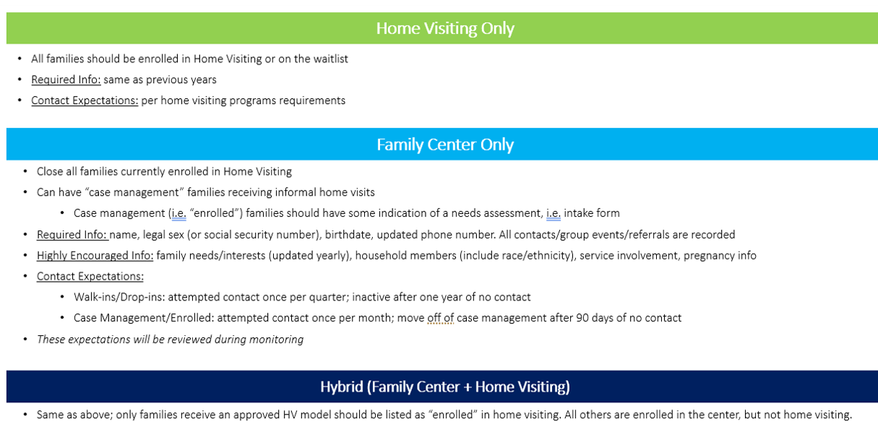
A few monitoring reminders:
- OCS is providing increased support for programs receiving a “red” status. These statuses should be factored into goals when submitting service profiles.
- If a visit or observation needs to be rescheduled, please make all attempts to reschedule 24 hours in advance
- Inform monitors of site closures and staffing changes as soon as possible

- Save the Dates
Roundtable/Site Directors Meeting: April 14th, July 14th
COACH Training: February 14th, 16th, 21st, 23rd with monthly COACH calls on the 1st Thursday of every month to provide ongoing support to staff
RELATE: For supervisors (recommended that you attend COACH first), forthcoming March date
Pre-Service: Quarterly series starting in March
Human Services 101: March 29th

